PRESS RELEASE

The all-in-one receiver KENWOOD KR-W8000SCD is recommended as the perfect stereo control center with smart radio, WLAN and Bluetooth® audio as well as numerous connections

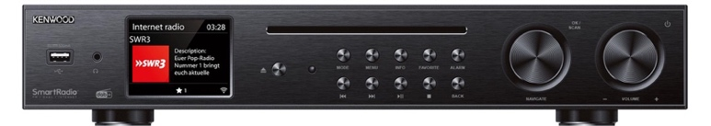
More than ever, modern hi-fi systems need a control center that is as versatile as possible, manages analog and digital sources, is equipped for audio streaming and yet is easy to use. With the new KR-W8000SCD stereo receiver, KENWOOD presents an inexpensive all-rounder for beginners and advanced players that meets exactly these requirements.

The integrated FM tuner and external components act as analogue players and can deliver their music via a universal high-level RCA and a phono MM input. The significantly more comprehensive digital section of the KENWOOD is able to stream Internet radio, podcasts, Spotify and Deezer via WLAN as well as from smartphones or tablets via Bluetooth®, but also to play CDs in the integrated, convenient slot-in Mechanism for feeding CD players, the reception of DAB+ radio programs and the data processing of external sources such as TV sets, satellite receivers, USB storage devices or music players of all kinds.

The navigation rotary controller and an eight-centimeter color display on the front of the device ensure convenient operation of all functions. It informs the listener about the available FM, DAB+ and Internet radio stations, shows the artist, album and title of the song currently playing and guides you through the menus, settings and information offered for all functions. It is operated either directly on the device, using the included IR transmitter or, particularly conveniently, using the free smartphone apps UNDOK or OKTIV. With an output power of 2 x 30 watts, the KENWOOD can reliably control most speakers, and an active subwoofer and headphones can also be connected.

The all-in-one receiver KENWOOD KR-W8000SCD will be available from specialist retailers from June 2024 for a recommended retail price of €xxx

Modell | Highlights in Ausstattung & Technik | Recommended Retail Price
KR-W8000SCD | • All-in-one receiver with WLAN, Bluetooth®, smart radio functions and slot-in CD player  • Internet radio and podcasts via WLAN  • Direct access to streaming services Spotify Connect, Spotify HiFi and Deezer  • Integrated DAB+ and FM RDS receiver  • 80 station memories (40 x Internet radio, 20 x DAB+, 20 x FM)  • Bluetooth® Audio-Streaming (A2DP)  • Inputs: Cinch analog, Phono MM, 2 x digital (coaxial/optical), USB (FAT16/32 / MP3)  • Outputs: RCA analog, subwoofer, 2 x digital (coaxial/optical), 3.5 mm ø headphones,  solid speaker terminals L/R  • 8 cm TFT color display; Aluminum front panel  • 2 x 30 watt output power (RMS)  • Integrated clock with time display in standby, sleep timer and alarm function  • Can be controlled remotely via the included infrared RC or smartphone apps UNDOK + OKTIV  • Removable rod antenna and connection for external FM/DAB antenna  • Antenna for WLAN/Bluetooth® and separate power cable included in delivery  • Dimensions (WxHxD): 430 x 68 x 303 mm

