PRESS RELEASE

The new party speaker KENWOOD AS-P200BT delivers great sound and the colorful light show to match thanks to its 50 watt amplifier and two-way system
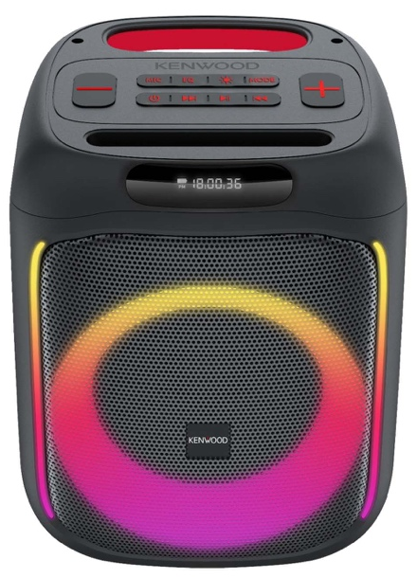
When warm sunshine entices you to the lake, the garden, the park or on vacation, mobile speakers are also in high demand for the appropriate musical accompaniment. Just in time for the 2024 open air season, JVCKENWOOD presents the new KENWOOD AS-P200BT party speaker.

A real treat both acoustically and visually, the KENWOOD AS-P200BT offers the best conditions for sonorous music sessions with a two-way system, DSP-optimized 50 watt amplifier, integrated lithium battery and numerous connections. The music program stored on the smartphone or streamed live finds its way to the speaker wirelessly via Bluetooth®. The KENWOOD AS-P200BT is equipped with an SD card slot, a USB port and sockets for connecting a microphone and an analog music source

A 165 mm woofer and two 25 mm tweeters ensure a powerful sound. If necessary, two of the KENWOOD AS-P200BT speakers can also be linked to form a stereo pair in TWS mode. In the party cellar at home, the AS-P200BT is ready for use when plugged into a socket; outside, the integrated 3,600 mAh lithium battery provides power. This is 100% charged within four hours and then offers a playing time of up to 10 hours.

The KENWOOD AS-P200BT also has the appropriate light show on board. Two vertical light strips to the left and right of the bass speaker and lighting behind them create impressive visual effects. A digital sound processor controls the different performances and colors to match the current music program.

The KENWOOD AS-P200BT party speaker will be available from specialist retailers from June 2024 for a recommended retail price of €xxx

Model | Highlights | Recommended Retail Price
AS-P200BT | • Party Speaker with DSP optimized 50 Watt amplifier  • 165 mm Woofer and two 25 mm Tweeters  • Inputs: Bluetooth®, AUX, Memory Card, Microphone, USB and TWS-Party mode  • Two speakers can be linked for stereo playback (TWS Party mode)  • Bluetooth® 5.0 Audio-Streaming (A2DP)  • Integrated 3.600 mAh-battery (7,4 V) for up to 10 hrs playtime with 4 hrs of charging time  • USB C power port (5 V, 2 A)  • DSP-controlled Lightshow with different settings and colors  • Light strips left -and right + speaker backlight  • Dimensions (WxHxD): 245 x 300 x 245 mm

