PRESS RELEASE

KENWOOD is expanding its smart radio range with the new portrait format stereo model CR-ST500S with a large color display, WiFi and Bluetooth® streaming as well as DAB+ radio
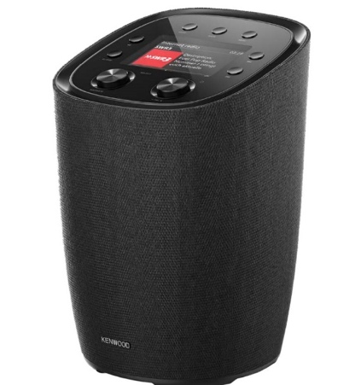
Thanks to Internet radio, audio streaming, DAB+ and the convenient operation via smartphone apps, classic radio devices have long since become digital all-round entertainers: They keep their owners entertained with either music, Internet radio and podcasts via WLAN or Bluetooth® streaming from their smartphone , tablet or PC as well as digital radio programs from the airwaves.

The new CR-ST500S stereo music system from the Japanese audio specialist KENWOOD also offers all of these playback options, but also sets fresh visual accents with its slim housing format and a 10 centimeter color display. All the important control elements are located on the top, which is slightly tilted forward - and the smart radio can alternatively be controlled by using the infrared remote control, included in delivery, or the smartphone apps UNDOK and OKTIV, which are available free of charge for both Android and Apple. All common streaming services can also be installed with mobile phones or tablets via a Bluetooth® connection - while the KENWOOD Smart Radio even establishes the connections to Spotify Connect, Spotify HiFi and Deezer directly itself.

A powerful 30 watt amplifier, two 50 mm mid-high speakers mounted in the front, a downward-firing 100 mm subwoofer and a passive radiator on the back that supports bass reproduction ensure excellent sound given the compact dimensions. The rod antenna included in the scope of delivery ensures interference-free reception of FM and DAB+ radio programs, which can be removed during stationary operation and replaced by an external antenna connected via cable.

The KENWOOD Smart Radio CR-ST500S will be available from specialist retailers from June 2024 for a recommended retail price of €xxx

Model | Highlights | Recommended Retail Price
CR-ST500S | • Internet radio playback via WLAN  • Bluetooth Audio-Streaming (A2DP)  • Direct access to streaming services Spotify Connect, Spotify HiFi and Deezer  • DAB+ and FM RDS receiver  • 30 watts total output power  • 2.1 speaker system with 100 mm ø woofer + passive radiator and two 50 mm  full-range speakers  • Integrated clock with sleep timer and various alarm functions  • 10 cm TFT color display  • Can be controlled remotely using the included IR remote control and UNDOK / OKTIV smartphone app  • removable rod antenna  • Dimensions (W x H x D): 180 x 273 x 180 mm | €

